UML is a notation that resulted from the unification of OMT (Object Modeling Technique [Rumbaugh et al., 1991]), Booch [Booch, 1994], and OOSE (Object-Oriented Software Engineering [Jacobson et al., 1992]).

The goal of UML is to provide a standard notation that can be used by all object-oriented methods and to select and integrate the best elements of precursor notations.

What Is Analysis and Design?

Analysis emphasizes an investigation of the problem and requirements, rather
than a solution. For example, if a new computerized library information system
is desired, how will it be used?

"Analysis" is a broad term, best qualified, as in requirements analysis (an investigation of the requirements) or object analysis (an investigation of the domain objects).

Design emphasizes a conceptual solution that fulfills the requirements, rather
than its implementation. For example, a description of a database schema and
software objects. Ultimately, designs can be implemented.

Analysis and design have been summarized in the phase do the right thing
(analysis), and do the thing right (design).
What Is Object-Oriented Analysis and Design?

During object-oriented analysis, there is an emphasis on finding and describing the objects—or concepts—in the problem domain.
For example, in the caseof the library information system, some of the concepts include Book, Library,and Patron.

During object-oriented design, there is an emphasis on defining software
objects and how they collaborate to fulfill the requirements.
For example, in the library system, a Book software object may have a title attribute and a getChap-ter method (see Figure 1.2).
Finally, during implementation or object-oriented programming, design objects
are implemented, such as a Book class in Java.

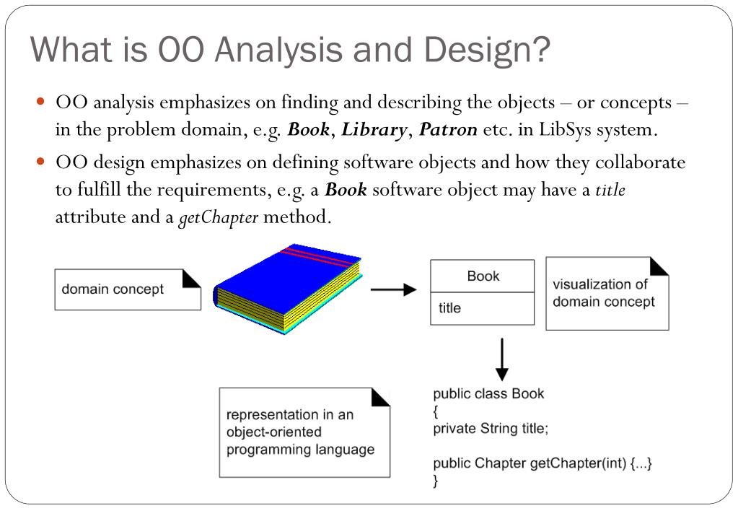
Figure 1.2 Object-orientation emphasizes representation of objects.

The Object-Oriented Software Development Method (OOSD) includes object-oriented requirements analysis, as well as object-oriented design. OOSD is a practical method of developing a software system which focuses on the objects of a problem throughout development. OOSD's focus on objects early in the development, with attention to generating a useful model, creates a picture of the system that is modifiable, reusable, reliable, and understandable — the last perhaps most important because the picture of a software system created by a development method must be an effective device for communication among developers, customers, management, and quality-assurance personnel.
Most object-oriented methods competing for the attention of the software developer actually apply traditional Structured Analysis (function-based), or variations of Structured Analysis, to requirements activity, and work through a transition process to an object-oriented design. In these methods the developer begins with functionally-based requirements analysis, and only reaches an object-oriented design by the intermediary step of converting a traditional, functionally-decomposed data flow diagram (DFD) to an object-oriented DFD (or equivalent). In this conversion process, objects are identified through a set of heuristics which group “transformations” in the DFD generated during requirements analysis. These methods carry a number of interesting but unfortunate burdens. Lower-level objects, which directly relate to real-world objects, are easily identified, but higher-level objects are generally more arbitrary, so that developers do not consistently identify a hierarchy of objects which achieves significant improvement in software engineering goals (e.g., reliability, maintainability, reusability).

The Software Crisis
Software Engineering Failures

Year 1900 bug
In 1992, Mary from Winona, Minnesota, received an invitation to attend a kindergarten. Mary was 104 at the time.
Leap-year bug
A supermarket was fined $1000 for having meat around 1 day too long, on February 29, 1988.
The computer program printing the expiration date on the meat labels did not take into account that 1988 was a leap year.
Interface misuse
On April 10, 1990, in London, an underground train left the station without its driver. The driver had taped the button that started the train, relying on the system that prevented the train from moving when doors were open. The train operator had left his train to close a door which was stuck. When the door was finally shut, the train simply left.
Security
CERT (Computer Emergency Response Team) at the Software Engineering Institute is a government-funded organization for assisting the community in dealing with security incidents, vulnerabilities, and security know-how. The number of security incidents reported to CERT from the United States increased from 252 incidents in 1990 to 21,756 in 2000, and more than 40,000 incidents were reported in 2001.
Late and over budget
In 1995, bugs in the automated luggage system of the new Denver International Airport caused suitcases to be chewed up. The airport opened 16 months late, $3.2 billion over budget, with a mostly manual luggage system.
Late and over budget (2)
In 2002, the Swanick Air Traffic Control system covers all the enroute air traffic over England and Wales. The system was delivered substantially over budget (cost £623 million, originally planned at £350 million) and 6 years late. Two major upgrades of the system were delivered after training of the traffic controllers had started.
On-time delivery
After 18 months of development, a $200-million system was delivered to a health insurance company in Wisconsin in 1984. However, the system did not work correctly: $60 million in overpayments were issued. The system took 3 years to fix.
Unnecessary complexity
The C-17 cargo plane by McDonnell Douglas ran $500 million over budget because of problems with its avionics software. The C-17 included 19 onboard computers, 80 microprocessors, and 6
different programming languages.

The process of Object Oriented software development
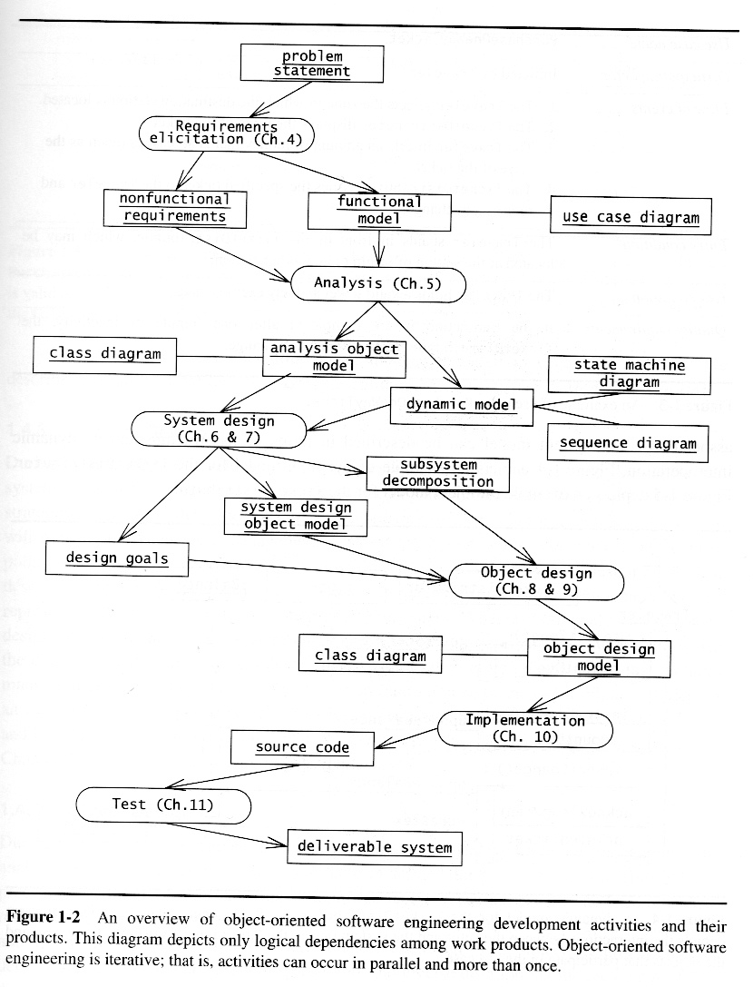

Distributed systems
Common architectural patterns for organizing the architecture of a distributed system:
Master-slave architecture
Master-slave architectures are commonly used in real-time systems in which guaranteed interaction response times are required. There may be separate processors associated with data acquisition from the system's environment, data processing and computation and actuator management. The 'master' process is usually responsible for computation, coordination and communications and it controls the 'slave' processes. 'Slave' processes are dedicated to specific actions, such as the acquisition of data from an array of sensors.
Two-tier client-server architecture
In a two-tier client-server architecture, the system is implemented as a single logical server plus an indefinite number of clients that use that server. Thin-client model, where the presentation layer is implemented on the client and all other layers (data management, application processing and database) are implemented on a server. Fat-client model, where some or all of the application processing is carried out on the client. Data management and database functions are implemented on the server. Distinction between thin and fat client architectures has become blurred. Javascript allows local processing in a browser so 'fat-client' functionality available without software installation. Mobile apps carry out some local processing to minimize demands on network. Auto-update of apps reduces management problems. There are now very few thin-client applications with all processing carried out on remote server.
Multi-tier client-server architecture
In a multi-tier client-server architecture, the different layers of the system, namely presentation, data management, application processing, and database, are separate processes that may execute on different processors. This avoids problems with scalability and performance if a thin-client two-tier model is chosen, or problems of system management if a fat-client model is used. Used when there is a high volume of transactions to be processed by the server.
Distributed component architecture
There is no distinction in a distributed component architecture between clients and servers. Each distributable entity is a component that provides services to other components and receives services from other components. Component communication is through a middleware system. Used when resources from different systems and databases need to be combined, or as an implementation model for multi-tier client-server systems. Benefits include:
- It allows the system designer to delay decisions on where and how services should be provided.
- It is a very open system architecture that allows new resources to be added as required.
- The system is flexible and scalable.
- It is possible to reconfigure the system dynamically with objects migrating across the network as required.
Distributed component architectures suffer from two major disadvantages:
- They are more complex to design than client-server systems. Distributed component architectures are difficult for people to visualize and understand.
- Standardized middleware for distributed component systems has never been accepted by the community. Different vendors, such as Microsoft and Sun, have developed different, incompatible middleware.
As a result of these problems, service-oriented architectures are replacing distributed component architectures in many situations.
Peer-to-peer architecture
Peer to peer (p2p) systems are decentralised systems where computations may be carried out by any node in the network. The overall system is designed to take advantage of the computational power and storage of a large number of networked computers. Most p2p systems have been personal systems but there is increasing business use of this technology. Used when clients exchange locally stored information and the role of the server is to introduce clients to each other. Examples:
- File sharing systems based on the BitTorrent protocol
- Messaging systems such as Jabber
- Payments systems, e.g. Bitcoin
- Databases, e.g. Freenet is a decentralized database
- Phone systems, e.g. Viber
- Computation systems, e.g. SETI@home
P2P architectures are used when
- A system is computationally-intensive and it is possible to separate the processing required into a large number of independent computations.
- A system primarily involves the exchange of information between individual computers on a network and there is no need for this information to be centrally-stored or managed.
Security issues:
- Security concerns are the principal reason why p2p architectures are not widely used.
- The lack of central management means that malicious nodes can be set up to deliver spam and malware to other nodes in the network.
- P2P communications require careful setup to protect local information and if not done correctly, then this is exposed to other peers.
Software as a service

